Muhammad Arsalan Zaheer 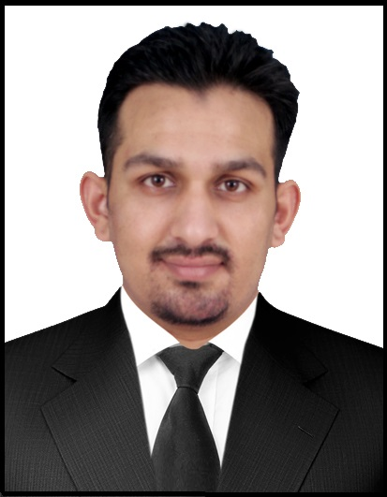

S/o Zaheer Ahmad
Date of Birth: February 25, 1985 Cell: 00-971-551854686
NIC: 17301-0737737-3 00-92-333-5089060
Nationality: Pakistani
Religion: Islam arsalanmalik1985@yahoo.com
Gender: Male House # D-998, Lane 19, Lala Rukh
Wah Cantt.
_________________________________________________________________________________________________________________________________________________________

Objective:
To pursue a career in a growing and dynamic firm, putting my theoretical knowledge into practical form, thus rendering all possible services in my capacity to the firm and to effectively contribute to the optimal growth of the company and to serve my nation.
Education:

- BSc Electrical Engineering (Jan2004-Dec2007)
CECOS University Peshawar. Percentage → 70%
PEC aCCREDIATED (eLECT/26268)

- HSSC (2001-2003) PAF Degree College Peshawar Percentage → 58%
- SSC (2001) Frontier Model School Peshawar Percentage → 77%

Experience:

Sr. RF Engineer (PTCL/Huawei CDMA/EVDO Project) at UCE Intl (Pvt) Ltd..
(September 2011 till June 2015)
- Managing the project & making the plans for smooth implementation of in time targets
- Sorting out the worst radio quality areas and propose optimization suggestion.
- Optimization of the coverage capacity & post processing logs.
- KPIs (Key performance Indicator) analysis, neighbor planning, adding & task creation/updating in OMC Optimizing coverage, as per Network requirement, problem identification and solution.
- Propose suggestion on how to solve coverage hole problems according to subscriber distribution.
- Assist in performing cluster optimization after addition or deletion of BTS/RF carriers.
- Solved problems like pilot pollution, distant server, coverage whole identification, excessive Neighbors / missing Neighbors, excessive SHO etc.
- EVDO Throughput testing, Network performance verification, EVDO performance optimization
- Prepare the RF Simulation Design for newly commissioned sites and share the Planning parameters for single site and Cluster DTs.
- Keep monitoring the health of network, Pilot pollution analysis and reduce the pilot pollution by soft and hard Para modification
- Propose suggestion on how to solve coverage hole problems according to subscriber distribution
- Co-ordination with the customer for final approval,
- KPI Optimization & Stats Monitoring.
- Perform traffic analysis and analyze DT reports.
- Conduct Interference testing
- Neighbor Optimization.

RF Engineer (PTCL/Huawei CDMA/EVDO Project) at UCE Intl (Pvt) Ltd..
(January 2010 till August2011)
- Swap & Pre-Optimization & post Optimization Cluster Drive Test CDMA/PTCL Project Central-I region.
- Single Site Drive Test CDMA/PTCL Project LTR, CTR, GTR & AJK region.
- Conduct Surveys and Check Subcontractor’s CER (Candidate Evaluation Report) for valid Candidates of New
Proposed Sites. Submit CER to Customer with suggestions about best candidate.
- Reports of the drive sites and their analysis.
- Fine tuning of Handovers parameters. Verifying that handovers between sectors and neighboring sites
Take place.
- Complaint resolving test Including Call failure, EVDO Throughput problem.
- Site Audit Report Including Site Configuration, Antenna heights, azimuth, electrical and mechanical tilts.
- Technical Site Survey (RF) & making TSSR after the TSS, Parameter Planning of AUGERE Project NORTH & Central I Region.

BSS Engineer in Uniques Construction
(April 2008-October 2009)
- Hands on Experience of Project Warid (Ericsson), Project ZONG (ZTE).
- Installation & Management of Base Transceiver Stations, Radio Base Stations equipped with Ericsson’s Equipment RBS2116 and RBS2216, and BTS equipped with ZTE’s Equipment BTS8112 and BTS8018.
- Call tests of installed BTS’s.
- Performing Sweep Test using the BIRD Site Analyzer (SA-2500EX, SA-6000EX).
- Installation and Management of Traffic node and Microwave links.
- Installation and alignment Experience of Ericsson M.W.
- Handling & maintaining the operation of sites and also making the sites fully clear for the PAT (85 PAT done successfully), making weekly progress report and expense sheet, managing the weekly movement of the teams.

Internee in NDC
(6 Weeks Training)
- Studied the Wireless Video transmission in defense sector (Tanks).
Internee in Fauji Foundation
(3 Months)
.
Training:

6 Weeks training on Radio Network Optimization
by Mr Abdur Razzaq ( Sr. RF Engr UCE Bangladesh)

- Optimization skills, Tools and software info.
- Case study of different problems in post drive test.
.
Technical Skills:

- Drive Test Tool(Pioneer, CNT, TEMS, Genex Probe)
- Reporting Tool(Navigator, CNA)
- MapInfo
- Alignment of Microwave Dish using MMU Card.
- Sweep Testing(VSWR Testing) using Bird Site Analyzer
- Sound Knowledge of MS Office.
- AutoCAD, C/C++.
Final Year Project:

- WiMax ( Study Based Project)
(Background, Types of WiMax network, IEEE standard and sub standards of WiMax, data rates offered & frequency used, WiMax protocols & architecture, Modulation, WiMax building blocks, comparison with other technologies & Applications)
Mini Project:

- D.C Motor Control via Computer.
Languages:

- English
- Urdu
- Punjabi
- Pushto

References:

- Can be provided on demand.

